Biodiversity in a Landscape Mosaic of Woodlands and Grasslands
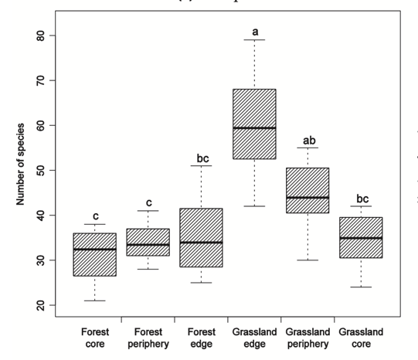
A mosaic of woodland and grassland patches supports a substantially higher biodiversity than would occur if the region was entirely woodland or entirely grassland.
Fig. 3: As Fig. 1 but for all species types in a mosaic of wood/grasslands
Peak flora biodiversity occurs at the grassland edges due to all specialist and generalist species being able to overlap successfully there.

While flora species are used as our illustrative example here, similar results are found for most species types, for example: birds (Melin et al 2018), bats (Heim et al 2015), mammals (Leopold 1923, Wirth et al 2008). However, insects and arachnids display variable responses (Guimarães et al 2007, Wirth et al 2008, Wimp et al 2019).
The review by Bennet et al (2006) concluded that the greatest overall biodiversity was achieved from a heterogeneous mosaic of wooded and grassed areas across the landscape (patches of varying sizes, shapes and at various distances). However, they noted that much of the available data were from combining individual patch studies and that more landscape-scale work was required for proper understanding of this diversity.
Further, Radford et al (2004) and Lindenmayer et al (2012) note broadly similar results for bird species and some non-avian species in eastern Australian landscape mosaics.
These results stand for practically all mosaic systems, not just grass and bush. For example, the coastal regions of oceans and other major water bodies typically are far more biodiverse than that found in the deeps or further inland.
Comments and Issues
The importance of components within the woodland or grassland are rarely discussed. Yet it is well known that a woodland, for example, is not homogeneous. Wander through Greens Bush and you will find a wide range of habitats, some on a scale of just a few tens of metres. The sandy rises are relatively uniform, with their dominant messmate and peppermint gum overstory and characteristic understory diversity. Drop into a moist gully and the environment changes rapidly to extensive ferns with an overstory of acacias, paperbarks and others. Traipse into upper Lightwood Creek and you could be be halted by a near-impenetrable barrier of tangled coral ferns. On strolling along the main track you may find yourself suddenly in a wonderland of grass trees.
Each of these microhabitats have their own characteristic species. Taken together, they contribute a substantial biodiversity to the landscape. Remove some and the net diversity of the region is compromised.
In other words, although our mosaic of bush and grassland can reasonably be expected to be providing substantial biodiversity, there are as yet unknown aspects of mosaic composition and variability within individual members, which mean that we may be able to do better than we have achieved from our essentially random mosaic generation.
Regardless, there are many things we can, and should be doing, to maximise what we have.

