Balcombe & Moorooduc Landcare Group
Invites you to a
Annual General Meeting and Workshops
Come and join our Landcare members for our AGM as well as be involved in a property tour showcasing a number of Landcare projects underway.
Aim will be overview of project through a walk and talk, including wicking gardens for vegies and orchard trees, hothouse set-up, a healthy wetland, nesting boxes for various species, running sheep to minimise lawn mowing, protected indigenous gardens, on-site Hip camping, protected orchard, making biochar for fertilizer including burning pits, worm-juice farming and composting, and numerous pets and wildlife
Post walk and talk and discussions, we plan to do some planting near the wetland which will link in well with discussions.
Please feel welcome to bring a friend or 2, as well as any kids to help feed the animals or catch frogs in the wetland.
Stay for a BBQ and a cuppa after the tour and planting session
Site Tour and Talk: 10.00 -12.00
Working bee: 12.00 – 12.30
BBQ and AGM Discussion: 12.30 – 14.00
Sunday 21st November 2021 at 10am-2pm.
Meet at 9 Century Drive, Mount Martha
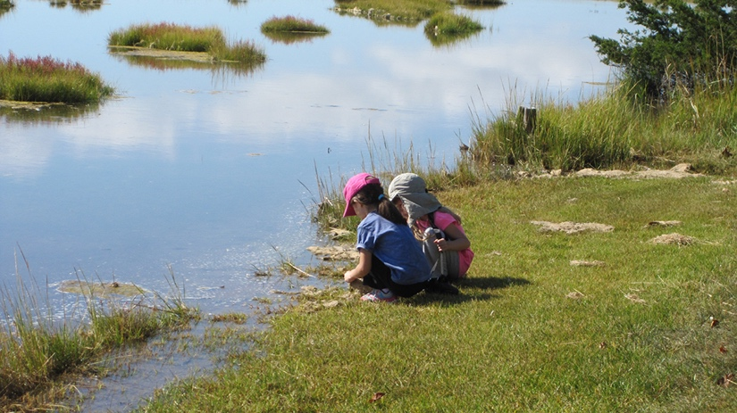
Join B&ML Group members for our AGM and get involved in discussions around environmental and sustainability related activities.
Wear comfy clothes and closed toe sturdy shoes and roll up your sleeves and meet your fellow Landcarers.
We invite you to stay after the working bee for a bbq lunch and catch-up
Please note: in line with COVID-19 Restrictions, we are only able to allow double vaccinated adults or those who have a medical exemption or underlying reason for not being vaccinated.
RSVP to Tony O’Connor: loctoc@bigpond.net.au, 0404 951 500

