Karamu Lookalikes in Need of Protection Gidja Walker SPIFFA
August 2016
I applaud the efforts of the Landcare Community and other Friends groups in their targeting of Karamu (Coprosma robusta) as a priority weed for removal. It poses a very real threat to the ecological integrity of the local Prickly Currant due to its ability to hybridise and pollute the gene pool of this species.

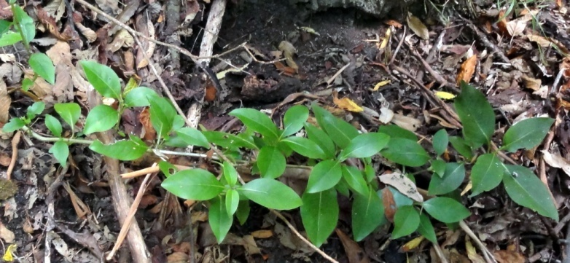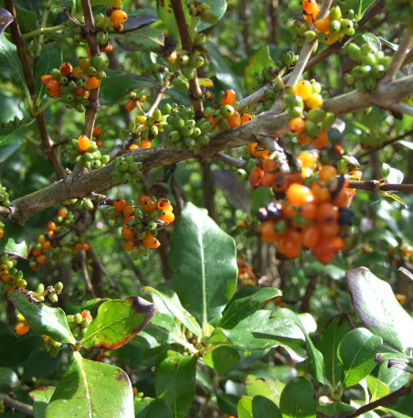

There are a couple of indigenous plants that are easily confused with Karamu and before planning to remove Karamu, bush regenerators should make themselves familiar with these and ensure everyone on site knows what they are looking for

The first is the Rough Coprosma (Coprosma hirtella)
I have noticed it’s disappearance across areas where woody weed control has taken place, to the point of local extinction on Arthur’s Seat. Recent reports are that it is now in decline in areas of Main Ridge & Red Hill. It only occurs in scattered localised populations of a few plants.
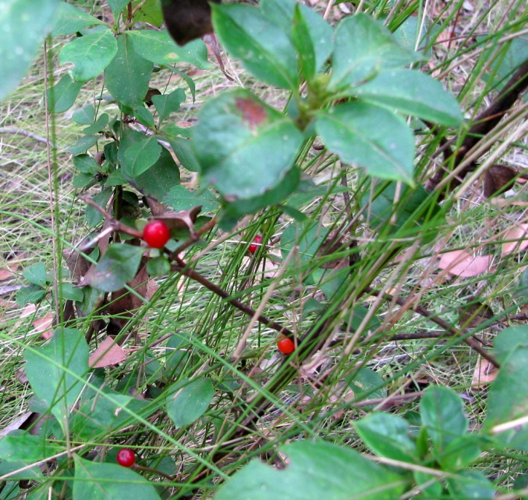
Rough Coprosma differs from Karamu in that its leaves are thicker, feel like sandpaper, are broad at the base and have long pointed tips. It’s bright red fruits and large leaves give it the appearance of being a weed. Propagation of this species and using it as a replacement in gardens and at a low density in reserves within the Arthurs Seat/Main Ridge area will aid its protection and the community’s familiarity of its characteristics
The second species is Muttonwood (Rapanea howittiana)
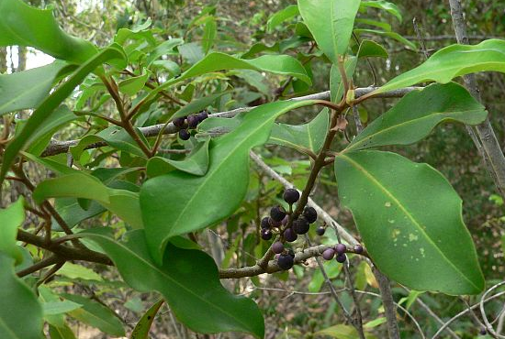
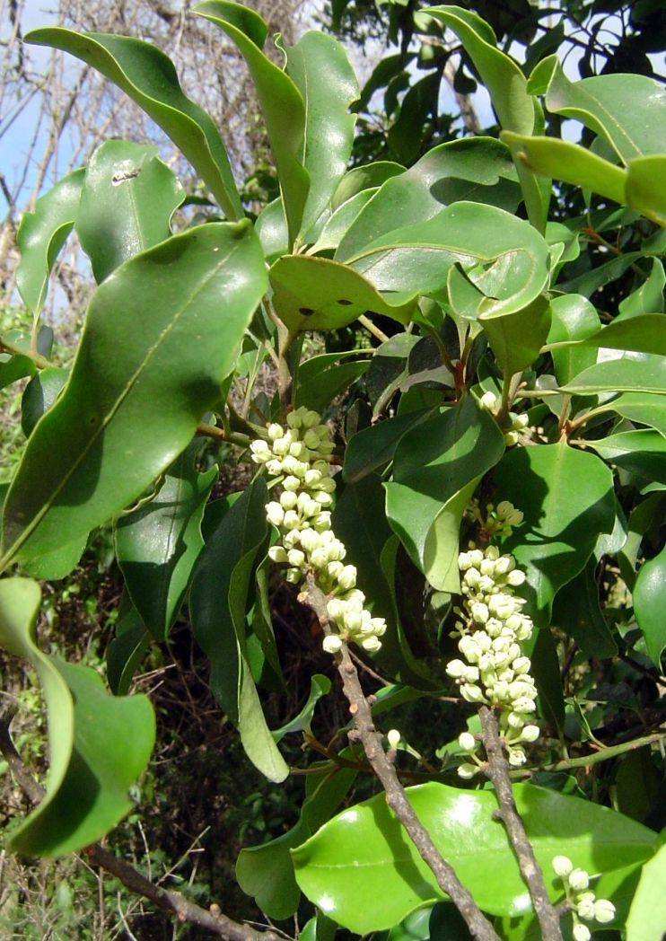
Muttonwood tends to grow into a dense grove. Its leathery leaves have a wavy margin and are darker green on the upper surface. Its pale flowers are followed by clusters of purple-violet fruits

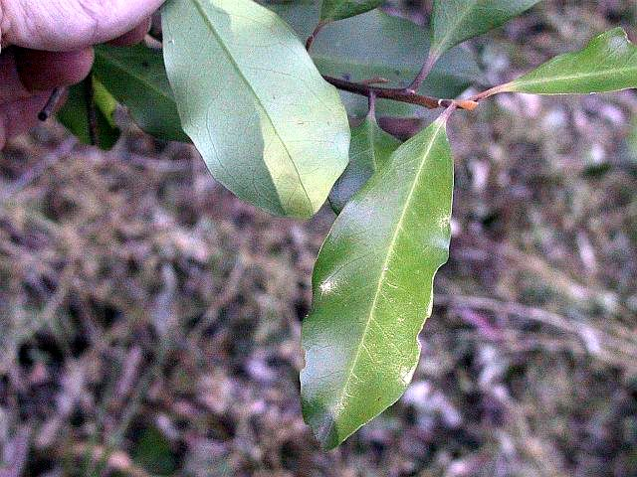

Many of our rarest local species can easily be mistaken for weeds. The first rule is always, if you are not sure what it is don’t pull it out. SPIFFA is happy to try and help identify plants. Send us a photo or bring a sample to our meetings.

